**Simple Machines:**

1. Simple Machine: **a mechanical device that changes the direction or magnitude of a force.**
2. Work:  **is done when a force that is applied to an object moves that object.**
3. Energy: **ability to do work**
4. Compound Machines: **a combination of 2 or more simple machines**

|  |  |
| --- | --- |
| There are six simple machines:    **1. Lever**  **2. Inclined Plane**  **3. Wedge**  **4. Screw**  **5. Wheel & Axle**  **6. Pulley** | Simple machines make work easier.  They make it easier to:   * Lift or move a heavy object * Push things apart * Cut or split objects * Hold an object together |

|  |  |  |  |
| --- | --- | --- | --- |
| **Simple Machine** | **How it Works** | **How it Makes Jobs Easier** | **Examples** |
| *Lever* | A lever is made of a stiff bar that rests on a fulcrum. The bar is the part of the lever that moves and the fulcrum does not move. | It helps you to lift or pry things open/apart more easily.  ***3 Parts of a lever:***  1. Fulcrum  2. Effort  3: Load/Resistance | 3 Classes of Levers: |
| *Inclined Plane* | A flat surface that is higher on one end. | It helps you push an object to a lower or higher place. | Staris, Ramp, Roof, |
| *Wedge* | Made up of two incline planes that form together to create 1 sharp edge | It helps you push two objects apart, or cut an object into pieces. It can also hold objects into place. | Axe, Knife, Tooth, Staple. |
| *Screw* | Made from an incline plane that winds around a cylinder; it has ridges unlike a nail. | It helps you hold objects together. It can also create holes. | Bottom of light bulbs, jar top, screw |
| *Wheel and Axle*  Wheel_and_Axle | Has two parts, the wheel and axle. The axle is a rod that goes through the wheel and helps the wheel turn. | It helps you to move or turn things. | Door knob, |
| *Pulley* | Made up of a wheel and a rope; the rope fits into the wheel and part of the rope is attached to an object. When you pull on one side of the pulley the wheel will turn and the object will move up, down, or sideways. | It helps you move objects up, down, or sideways. They are good for moving objects in hard to reach places.  ***Block and Tackle:*** Multiple pulleys put together. | Crane, elevator, |

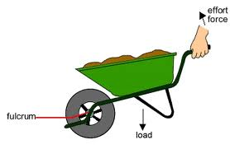

Lever

Incline Plane

Wheel and Axle

Compound Machines:

Identify the Simple Machines in each:

1. Scissors 3.Wheelbarrow

Wedge

Lever

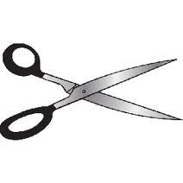

1. Bicycle 4. Shovel

Wedge

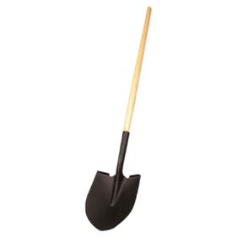

Lever

