Name: ______________________
Cell Unit Study Guide -KEY

- What is photosynthesis? The process of capturing energy from the sun to convert it into food for cells.

- Which microorganism uses flagella to move and is a type of algae? volvox

- Who first looked at cells through a microscope? Hooke

- What is an analogy for the nucleus and why? Answers may vary – example: the mayor of a city is like a nucleus because he makes decisions for the town just like a nucleus makes decisions for the cell

- What kinds of cells don’t have a nucleus? prokaryotic

- What two parts do you hold to carry a microscope? Base and arm

- What is the difference between the rough ER and the smooth ER and what are their functions? Rough ER has ribosomes; smooth ER does not have ribosomes – both transport nutrients and proteins throughout the cell

- Which single celled organism acts like a multi-cellular organism? How does it do this? Volvox- by living in a colonyand working for the good of the cell

- Name two organelles found in a plant cell but not an animal cell. Chloroplasts, cell wall

- What is the order of organization in the human body? Cells tissues organs organ systems organism

- List the 3 parts to the cell theory:
- the cell is the basic unit of structure and function of all living things
- all living things are made of cells
- all cells come from other cells
- What did Schwann, Schleiden, and Virchow each contribute to the cell theory?
- Schwann- found that all animals are made of cells
- Schleiden- found that all plants are made of cells
- Virchow- found that all cells come from other cells
- What is the function of the mitochondria? -it uses respiration to create energy for the cell; more active cells require more mitochondria

- Why do plant cells not typically need lysosomes? -plant cells create their own food through photosynthesis, so they do not need to digest food material, which is what lysosomes do

- How do you find the power of magnification? –multiply the power of the objective lens by the power of the ocular lens

- Explain the difference between diffusion and osmosis. –diffusion: the movement of molecules (other than water) from areas of higher concentration to lower concentration
Osmosis: the movement of water molecules from areas of higher concentration to lower concentration (the diffusion of water molecules)

- What is active transport? –the net movement of molecules across a semi-permeable membrane, using the cells energy

- Explain the difference between autotrophs and heterotrophs. –autotrophs can make their own food, often by photosynthesis; heterotrophs cannot make their own food and therefore have to seek out and find food

- What is phagocytosis and which unicellular organism uses it most often? -the engulfing of solid particles by reshaping the membrane; the amoeba uses this to eat (deadly amoeba hugs)

- List and describe the three methods of movement used by unicellular organisms:
-cilia
-flagella
-pseudopodia
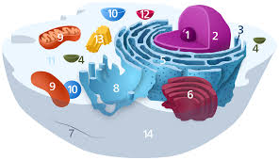
Labeling: Name all the cell parts using the diagram above and the few hints provided.

1.nucleolus
2. (entire organelle)nucleus
3. (tiny organelles)ribosomes
4. (break down foods)lysosomes
5.rough endoplasmic reticulum
6.golgi body
8.smooth endoplasmic reticulum
9.mitochondria
10. (store water)vacuole
11. cytoplasm
14.cell membrane

True or False – If false, change the statement to make it true.

26. Ribosomes are only in plant cells. False –they are found in both plant and animal cells

27. Leeuwenhoek discovered the first live cell. True

28. Microscopes make distant objects appear closer. False –they make smaller objects larger

29. Cells that require more energy to function will have fewer mitochondria. False –they will need more

30. Volvox and euglena use the same mode of transportation. True

Matching: Match the organelle to its function

_G__ cell membrane
_H__ cell wall
_L__ chloroplasts
_N__ cytoplasm
_A__ golgi apparatus
_D__ lysosome
_M_ mitochondria
_F__ nuclear membrane
_I__ nucleolus
_E__ nucleus
_J__ smooth endoplasmic reticulum
_B__ ribosome
_K__ rough endoplasmic reticulum
_C__ vacuole

- Receives and packages proteins before sending them to their destination
- Creates proteins; bound or free
- Stores water for the cell
- Breaks down food; usually only in animal cells
- Controls all cell functions
- Provides a protective layer around the nucleus
- Semipermeable; allows certain things to pass in and out of the cell
- Provides shape and support for the plant cell
- Creates the ribosomes
- Transports proteins and other materials throughout the cell; lacks ribosomes
- Transports proteins and other materials throughout the cell; contains ribosomes
- Captures energy from the sun to create food for plant cells
- Uses food to create usable energy for the cell
- Jelly-like substance that holds organelles in place; allows movement of molecules within the cell

Fill in the table with information about each unicellular organism.
 | How does it eat? | How does it move? | How does it reproduce? | Any other characteristics?
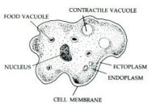 | Heterotroph- phagocytosis | Pseudopodia | When it gets too large, it splits | Found in fresh water, unicellular
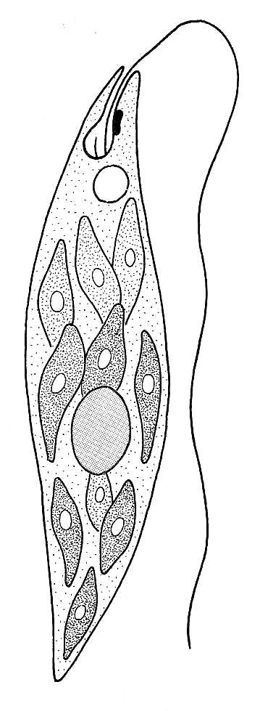 | Heterotroph (phagocytosis) and autotroph (photosynthesis) | Flagella | When it gets too large, it splits | Found in fresh and salt water, unicellular, has a red eye spot
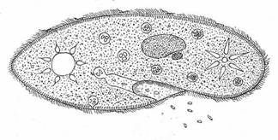 | Heterotroph- has a mouth pore | Cilia | When it gets too large, it splits | Found in fresh water, unicellular
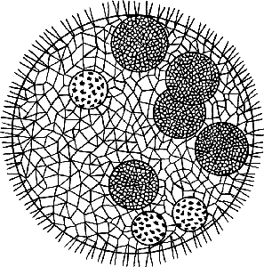 | Autotroph –photosynthesis | Flagella | Daughter colonies are released when they are mature enough | Found in fresh water, a type of algae, has eye spots

