Name:

# Midterm Exam Review

**Chemistry**:

1. State the steps to the scientific method below.
2. Know independent variable; Dependant variable; Observation; control and constants
3. List the 6 characteristics of all living things.
4. What are the 2 characteristics of an organic substance?
5. What are the 2 characteristics of an inorganic substance?
6. List and state the function the four organic macromolecules.

|  |  |
| --- | --- |
| Macromolecule: | Function: |
|  |  |
|  |  |
|  |  |
|  |  |

1. State the subunits and examples of lipids:
2. Draw and label a lipid below:
3. State the subunits and examples of carbohydrates:
4. What is the difference between glucose and glycogen?
5. What is the function of glucose, glycogen, cellulose and starch (**you should know that these are all carbohydrates)**?
6. What are the 2 subunits of proteins?
7. How can you destroy a protein and what is it called (looking for 2 ways)?
8. What is the function of hemoglobin, enzymes and insulin **(you should know that these are all proteins)**
9. Draw and label the how an enzyme works (enzyme, substrate, enzyme substrate complex, enzyme (again) products)
10. Name and explain the 2 types of enzyme theories
11. What is activation energy and why is it important for enzymes?
12. What factors affect enzymes? How do you tell when an enzyme is working most optimally?
13. State the 4 organic macromolecules (again) and list the elements that make them up:

|  |  |
| --- | --- |
| Macromolecule: | Elements: |
|  |  |
|  |  |
|  |  |
|  |  |

1. What does a brown paper bag test for and what color does it turn?
2. What does Benedicts solution test for and what color does it turn?
3. What does Iodine test for and what color does it turn?
4. What does Biuret’s test for and what color does it turn?

C2:

1. For the following set of statements, place P (prokaryotic) or E (eukaryotic) on the line.

____ larger ____ nuclear membrane and nucleoli is present

____ no nuclear membrane or nucleoli ____ no membrane bound organelles

____ Membrane bound organelles ____ smaller

1. Draw how you would see the letter ‘e’ in a microscope.
2. State the function of the following:
   * Diaphragm
   * Objective
   * Stage clips
   * Stage
   * Ocular
3. How do you determine magnification of a microscope?
4. Label the microscope below:

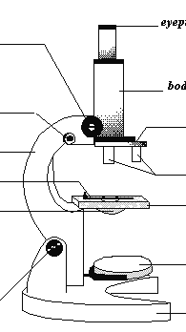

1. Place the following in order from largest to smallest:

Cell, organ, organ system, organelle, body, tissue

1. Why are all animal cells shaped differently?
2. Why are all plant cells shaped differently?
3. List all of the ways cells are bale to communicate with one another.
4. Why are receptor proteins so important?
5. What is homeostasis? What are the four things that must be maintained?
6. Fill in the following Venn diagram about plant and animal cells:
7. State the function of a cell wall and what it is made up of.
8. State the function of the plasma membrane and what it is made up of.
9. What is passive transport?
10. What would happen to the cells if a freshwater plant were placed into salt water?
11. For the following, place P (passive transport) or A (active transport):

____ no use of energy ____ proteins provide a path for some substances to pass

____ ‘lock and key’ theory ____ net movement from high concentration to low concentration

____ enzymes ____ uses energy

____ Diffusion ____

____

____ net movement from low to high concentration

1. Name and explain the 3 ways substances can enter the plasma membrane through passive transport.
2. State the function of the mitochondria.
3. Name and explain the 2 processes collectively called cellular respiration.
4. Write the chemical equation for aerobic respiration below:
5. Circle the reactants in the equation above.
6. Write out the words for the chemical equation for aerobic respiration below:
7. The majority of cellular respiration takes place in what organelle?
8. What factors effect cellular respiration?
9. State the function of the chloroplast.
10. Write the chemical equation for photosynthesis below:
11. Circle the products in the equation above.
12. Write out the words for the chemical equation for photosynthesis below:
13. The majority of photosynthesis takes place in what organelle?
14. What factors effect photosynthesis?
15. How do plants take in and release CO2 and release O2?
16. In the list of substances below, circle the things that would currently undergo cellular respiration:

Carnation Dog Rock Fruit loops grass

Mineral Your best friend Tree your book CD

1. What is ATP composed of?
2. How do we get energy from ATP?
3. In the following Venn diagram, compare and contrast aerobic and anaerobic respiration. I want 3 facts contrasting in each and at least one similarity.
4. Draw the carbon cycle below:
5. State the function of the nucleus.
6. State the function of the ribosome.
7. State the function of the vacuole.
8. The next page will be entirely blank. I want you to draw and label a plant cell with as much detail with all the organelles that I gave you in this class. (For example, all the parts of a chloroplast should be labeled… feel free to draw more than one chloroplast, but you must label one.)

**Genetics:**

G1

1. What is the shape of DNA?
2. What is a nucleotide?
3. There are 3 components to a nucleotide, what are the 3 parts?
4. Draw a segment of DNA including all 4 nitrogen bases.
5. What 2 people discovered the structure of DNA?
6. What 2 parts of DNA make up the ‘backbone’?
7. Name all of the nitrogen bases found in DNA.
8. The following are ½ a strand of DNA. Place the complimentary strand.
   * ATCGGTCAGCTCGTA
   * ACGTTGCATCGATCG
   * ACGTATAGCGCTAGC
   * TGCATAGCAATCGAC
9. How many hydrogen bonds are between each complimentary base?
10. Why are hydrogen bonds between the nitrogen bases?
11. What is DNA replication?
12. List the 4 steps in DNA replication.
13. Name, explain **and give an example of** the 4 types of mutations.
14. What does RNA consist of? I am looking for details here… 6 things.
15. What is the difference between a codon and an anticodon?
16. Transcribe the following DNA strand:

A-T-C-G-T-A-A-T-C-G-G-C-T-A

1. There are 2 processes involved in protein synthesis: translation and transcription. What happens during transcription?
2. What happens during translation?
3. Translate the following RNA strand:

A-U-G-G-C-A-U-U-A-G-C

1. Why do we need protein synthesis?
2. Why is DNA so important to humans?
3. Why is there always a start message and a stop message?

The chart below matches messenger RNA codons with amino acids.

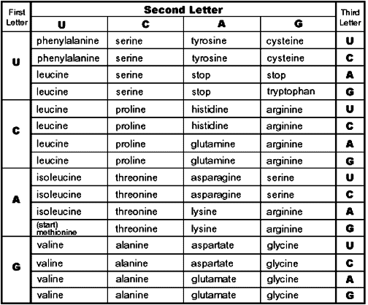

1. A DNA strand has the codon TCA. According to the chart, the **corresponding** messenger **RNA** codes for which amino acids?
2. A DNA strand has the codon AGC. According to the chart, the **corresponding** messenger **RNA** codes for which amino acids?
3. A DNA strand has the codon GGT. According to the chart, the **corresponding** messenger **RNA** codes for which amino acids?
4. mRNA works in what part(s) of the cell?
5. tRNA works in what part(s) of the cell?
6. Draw and label the different parts of a ribosome. State how its function is related to its structure.
7. Draw and label the different parts of a chromosome. Explain how its structure is related to its function.
8. List 3 characteristics of asexual reproduction.
9. During the cell cycle, what does the following represent:
   * G1
   * S
   * G2
   * G0
10. The following pictures represent mitosis. State 2 things (to the right of the picture) that is going on in each picture:



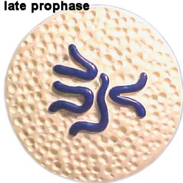

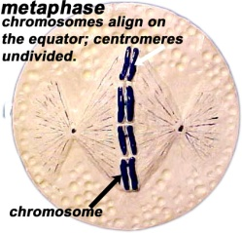

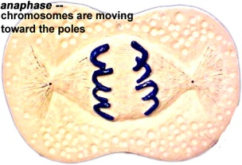



1. What part of the cell deals with mitosis?
2. What is the end result of mitosis? (Do not forget chromosome number)
3. The following pictures represent meiosis. State 2 things (to the right of the picture) that is going on in each picture

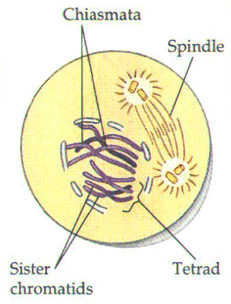

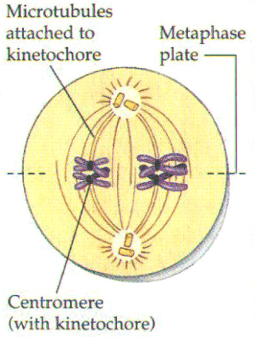

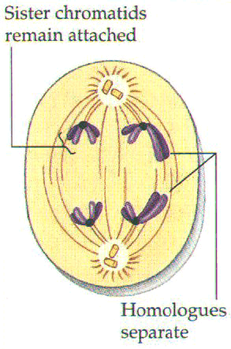

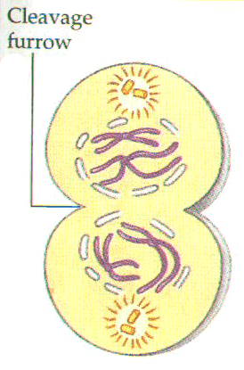

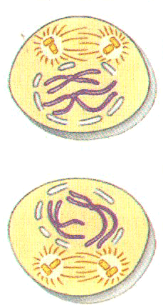

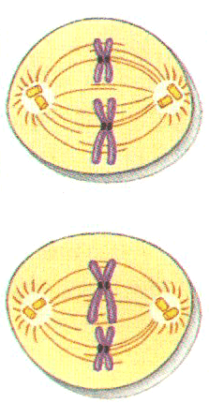

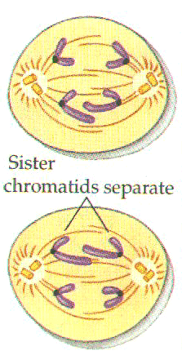

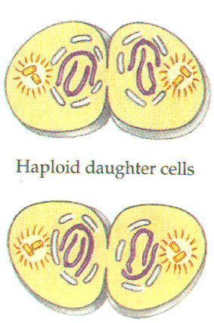

1. What is the end result of meiosis? Do not forget chromosome number and haploid/diploid.
2. Use the following Venn diagram to compare and contrast sexual and asexual reproduction. I was 3 contrasts and 2 similarities.
3. What happens during crossing over?
4. What process would ***most likely*** occur after DNA replication?
5. How many chromosomes would a human diploid cell have?
6. How many chromosomes would a human haploid cell have?
7. How many autosome chromosomes do humans have?
8. How many gamete chromosomes do humans have?
9. After fertilization, how many chromosomes would be present in a human?
10. The majority of our cells are (circle one)

Haploid Diploid

1. Gametes are (circle one)

Haploid Diploid

1. How many chromosomes would you find in a human sperm cell?

G2:

1. What is the difference between differentiated and undifferentiated cells?
2. Why isn’t every gene in a differentiated cell being expressed at the same time?
3. When does cell differentiation occur?
4. Why is cell differentiation important?
5. How does cell differentiation link to gene regulation?
6. What are stem cells and why are they important?
7. What is the controversy behind stem cell research?
8. What are the pros and cons for using stem cells?
9. What is the importance of homeotic genes?
10. In a diploid human cell, how many autosomes are there?
11. In a diploid human cell, how many sex chromosomes are there?
12. In a haploid human cell, how many autosomes are there?
13. In a haploid human cell, how many sex chromosomes are there?