MICROSCOPE WORKSHEET Name______________________
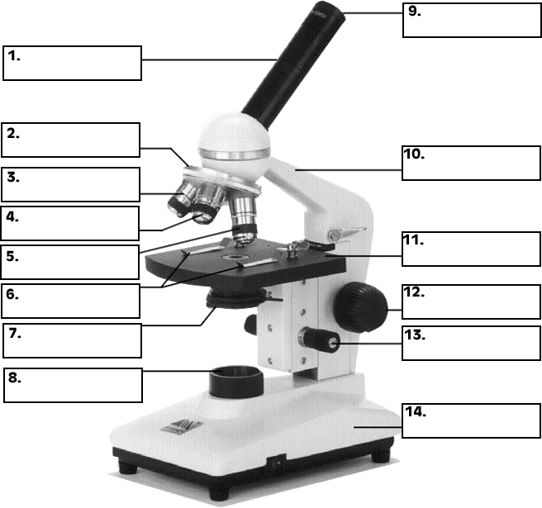
Microscope Use
15. The objectives are attached to what part of the microscope (it can be rotated to click lenses into place?) ____________________________________________
16. The type of microscope used in most science classes is the ______________ microscope.
17. You should carry the microscope by the ____________ and the ______________.
18. When focusing a specimen, you should always start with the _____________ objective.
19. A microscope has an ocular objective of 10x and a high power objective of 50x, what is the microscope's total magnification? ___________
20. When using the high power objective, only the _______________ knob should be use

