Biology Goal 1Guided Notes Name ____________________
- What is the function of the following organelles?
  - Nucleus: ___________________________
  - Plasma membrane: ___________________________
  - Cell wall: ___________________________
  - Mitochondria: cellular respiration; ___________________________
  - Vacuoles: stores ___________________________
  - Chloroplasts: ___________________________
  - Ribosomes: ___________________________
- Label the cell below
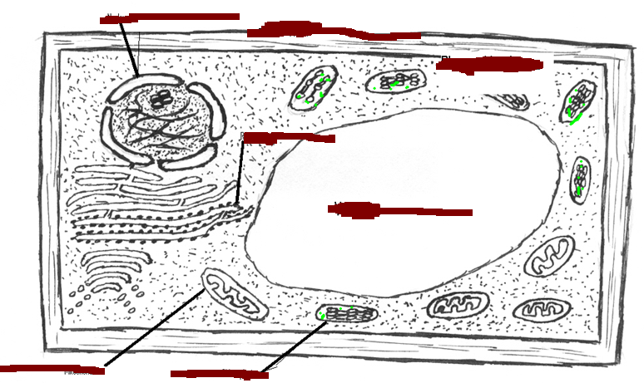
- The structure of the organelle determines it __________________ (Example: folded inner membrane in __________________ increases __________________ for energy production during __________________.
- These organelles interact to carry out functions such as _________________________, transport of molecules, _________________________, and synthesis of new molecules. (Example: _________________________, which are assembled by the _________________________ and used as enzymes for energy production at the _________________________,).
- Microscopes
  - Total Magnification = _________________ X _______________________
  - If eyepiece is 10x and the objective is 40 x then the total magnification is ______________________________
  - Electron Microscopes have ________________ magnification than light microscopes.
  - They allow one to see the organelles and viruses
  - Two types: ______________________ and ________________________________
- How to use a microscope
- Place _______________________________
- Move to ___________________________________________________.
- Move the _________________________ until you see the object.
- Use the _____________________________ to focus
- If you wish to see on high power, move to high and _______________ use the _________________________________________.
- Prokaryotic Cells
  - Prokaryotic cells are _______________________________ than eukaryotic cells.
- Compare the structure of prokaryotic and eukaryotic cells :
  - Presence of ___________________________ – ________________, _________________________, ________________________, and ______________________________ are not present in prokaryotes.
  - ___________________ are found in both.
  - _____________ and ___________ are present in both, but are not enclosed by a membrane in prokaryotes.
  - _______________DNA strands called plasmids are characteristic of prokaryotes.
  - Prokaryotic cells are ____________________.
- Plant Cells vs. Animal Cells
Plant Cell | Animal Cell

- Cell Differentiation
  - Multicellular organisms begin as ________________________ masses of cells
  - ________________________________________ and ______________________________ determines the differentiation of cells and ultimately their specialization.
  - During the process of differentiation, only___________________ parts of the DNA are ________________; the parts of the DNA that are activated determine the ___________________and specialized _______________________ of a cell.
  - Because all cells contain the same DNA, all cells initially have the potential to become any type of cell; however, once a cell differentiates, the process cannot be reversed.
  - Nearly all of the cells of a multicellular organism have _______________________ the same chromosomes and DNA.
  - _________________ parts of the genetic instructions are used in different types of cells, influenced by the cell's _____________________________________________.
- Cell Specialization
  - Red blood cells carry _________________________
  - White blood cells fight _________________
  - Muscle cells __________________
  - Nerve cells carry ___________________
  - Xylem carries ___________________
  - Phloem carries _________________________
  - Label the pictures
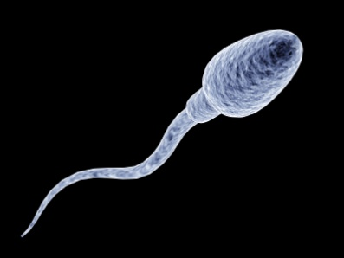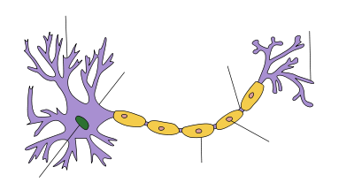
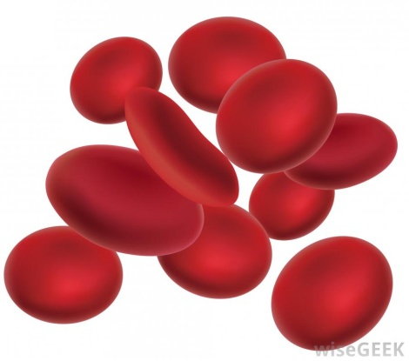

- Cell communication
  - Do cells communicate? _________________
  - ______________________________________ may be released by one cell to influence the development and activity of another cell.
- Stem Cells
  - Stem cells :
    - ____________________________________ that continually reproduce themselves
    - Have, under appropriate conditions, the _________________________________________ into one or more types of specialized cells.

  - _______________________________ which have not yet differentiated into various cell types are called embryonic stem cells.
  - Stem cells found in organisms, for instance in bone marrow, are called ______________________________________
  - Scientists have recently demonstrated that stem cells, both embryonic and adult, with the right laboratory culture conditions, differentiate into specialized cells.
- Homeostasis
- Cells use __________________ to regulate cell pH . Buffers are __________________________________________.
- Cells can respond to ______________________, glucose levels, and ______________________ in organisms.
- Active and Passive Transport

- Osmosis: Movement of ____________________________
  - If you place a cell into a very salty or sugary solution, the water will move _____________________. This makes the cell ____________________
  - If you place a cell into a solution that has less solute than the cell has, then water will move ________________and the cell will __________________________.
  - Freshwater moves towards _____________________.
- Plasma Membrane
  - The plasma membrane has a double layer of ____________________________________________________ The membrane controls what ______________________________________ the cell.
- Cell Cycle
  - Label the cell cycle

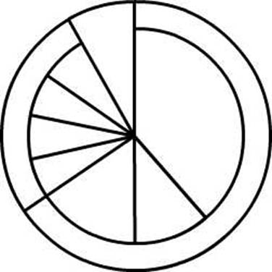

  - Cell Cycle: A series of events in the life of a cell
    - Interphase: _____________________, ___________________, _____________________
    - Mitosis: Prophase, Metaphase, Anaphase, Telophase
    - Cytokinesis
  - Cells spend the majority of their life in__________________________________
- Mitosis
  - __________________________ cells use mitosis for __________________ and ________________________
  - Unicellular organisms use mitosis for ___________________________________________.
  - One cell makes __________________ Identical daughter cells
  - Diploid cell 2 diploid cells
- Structures of unicellular organisms help that them survive
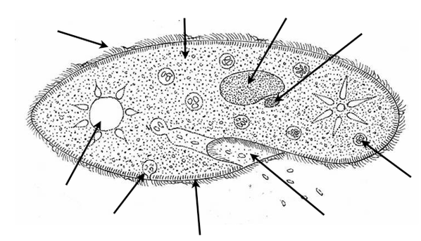
  - Contractile Vacuole: regulates amount of _____________________
  - Cilia: _____________________ for movement
  - Flagella: _________________________ for movement
  - Eyespots: Detect ______________________
  - Pseudopods: “ _______________________________
- Adaptive Bahaviors
  - Chemotaxis: Response to ___________________
  - Phototaxis : Response to_______________________
  - Geotaxis : Response to____________________________

