In your own words, describe each of the following modes of inheritance:

Simple Mendelian –

Incomplete Dominance –

Codominance –

Multiple Alleles –

Sex-linked –

Polygenic –

Identify each of the following descriptions/traits as one of the modes of inheritance above. What “letters” would you use to represent genotypes for each of the modes?

1. Blood type consists of 3 alleles, two of which are dominant. When both dominant alleles are passed down, they are both present in the phenotype.

2. Trait is more common in males than in females. Only females can be carriers because they receive two alleles of the trait while males only receive one.

3. Austrian Monk determined this type of inheritance after working with pea plants. It consists of genes with 2 alleles, one of which is dominant over the other (recessive).

4. In snapdragons, when a red flower is crossed with a white flower, the result is all pink flowers. When crossing two pink flowers, it is possible to get every color: red, white, and pink.

5. More complex mode of inheritance in which many different genes determine a trait.

Match the following disorders/diseases/traits with their inheritance pattern.
6. Huntington’s Disease  7. Sickle Cell  8. Hemophilia  9. Tay Sach’s  10. Cystic Fibrosis  11. Color-blindness  12. Baldness | Recessive  Dominant  Sex-linked

Each of the following disorders/diseases is caused by NONDISJUNCTION.
13. Define nondisjunction. When does it occur?

Describe how each of the following is caused (what is missing/extra?).

14. Turner’s Syndrome –

15. Down Syndrome –

16. Klinefelter’s Syndrome –

Practice with the following Punnett Square problems. For each problem, identify the following:
- the mode of inheritance
- the letters you are using to represent alleles
- the P1 (parental) genotypes
- show the Punnett Square
- the genotypic ratio of the offspring
- the phenotypic ratio of the offspring
Make sure to answer any additional questions that are included.

17. Cross a bald man with a female who is homozygous and has hair.

18. Cross a female who has hemophilia with a male who does not have hemophilia.

19. Cross a white snapdragon with a pink snapdragon.

20. Cross a mother with type A blood and a father with type B blood. There are 4 possible crosses – show all of them. Is it possible for a child to be born with type O blood?

21. Smokey, the gray cat, had a mom with white fur and a dad with black fur. Cross Smokey with another gray cat.

22. In eagles, sharp claws are dominant over dull claws. Cross a homozygous sharp clawed eagle with a homozygous dull clawed eagle.

23. In butterflies, orange wings are dominant over white wings. Cross two heterozygous butterflies.

24. A baby with type O blood is born from a woman with type B blood. Can a man with type A blood be the father?

25. A baby with blood type AB is born from a mother with type B blood. Can a man with type O blood be the father of the child? There are two possible crosses.

26. Cross a female who is a carrier for colorblindness with a male who has normal vision.

27. In pigs, curly tails are dominant over straight tails. Cross a heterozygous, curly tailed pig with a pig that has a straight tail.

28. Cross 2 pink snapdragons.

29. In fruit flies, red eye color is dominant over white eye color. Cross a white eyed male with a heterozygous female.

30. Squidward’s son is heterozygous for light blue skin. Show the cross between Squidward Jr. and a girl with light green skin.

31. In bees, loud buzzing is dominant over soft buzzing. Cross a homozygous loud buzzing bee and a homozygous soft buzzing bee.

32. Cross a hemophiliac male with a carrier female.

33. In shorthorn cattle, the mating of a red bull and a white bull produces a roan calf – has both white and red. Cross a roan cattle with a red cattle.

34. Mice can be black, white, or gray. Cross two gray mice.

35. Cross a woman with type O blood and a man with type AB blood.

36. Cross a woman heterozygous for Type A blood and a man with Type AB blood.

Fill in the chart below showing which blood types can donate to other blood types.
 |  | Recipient
37. |  | A | B | AB | O
Donor | A
 | B
 | AB
 | O

Use the pedigrees to answer the questions which follow.
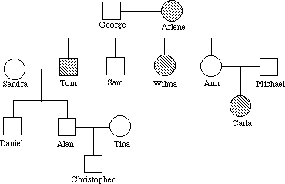
38. How are George and Carla related?

39. Is this trait dominant or recessive?

40. Determine the genotypes of as many of the individuals as possible. Write the genotypes near the names.

41. How is Christopher related to Ann?

42. Which individuals have the trait being represented?

Read the following scenario and develop a pedigree for it. Make sure to use the correct symbols, linkages, and fill in individuals who have the trait.

Grandfather and Grandmother Smith smiled a lot and showed off their dimples each time. They had a son named John, who had dimples, and a daughter named Julie, who did not. Julie died at an early age, but her brother John Smith met and married Mary Jones because she had the most beautiful dimples when she smiled. They had 5 children, 2 girls and 3 boys. Only one of their sons, Tom, had dimples, but both girls, Judy and Kay, had dimpled smiles. Their sister June lacked dimples. After college, Tom met and married Jane Kennedy who also had dimples. They had 3 children, all girls, who shared their parent’s dimpled smile. Tom’s sister Kay married a lawyer named James who seldom smiled and didn’t have dimples. Their only son Matthew was like his mother when he smiled. Judy never married. Tom’s sister, June, married a doctor and had 5 children. Three of the children were boys: Jay, Fred, and Mike. Mike and Fred had dimples like dad, but Jay’s smile was like his mom’s. One sister, Susan, had dimples, but the other, Katherine, didn’t.

Label as many genotypes as you can.

43. How many generations are in your pedigree?

44. Is the presence of dimples a dominant or recessive trait? How do you know?

45. Rats can produce many more offspring than humans, making a pedigree more difficult to manage. A researcher has 4 female white rats named April, May, June, and July. One night, the cage was left open in the lab and a brown rat got into the females’ cage. Six weeks later, the rats had litters of baby mice of varying colors. Two of the offspring managed to reproduce before the researcher was able to sort out the mess.

Determine genotypes of the rats in the pedigree.

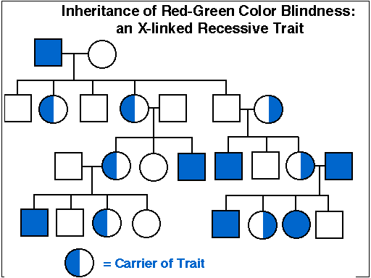
46. What type of inheritance is shown in the pedigree?

47. Identify the genotypes of all of the individuals.

48. How did the males get the trait?

49. How many generation are shown?

50. Show the Punnett square for individuals II-4 and II-5. What was the likelihood for individual III-3 to be homozygous dominant?

Karyotypes

51. What is a karyotype?

Identify whether each of the following karyotypes is from a male or female. Describe any chromosomal abnormalities that are identifiable in the karyotype.

52. 53.
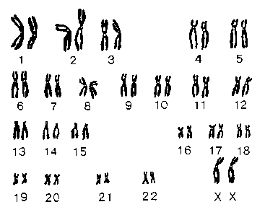
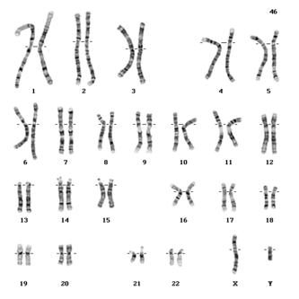

54. What is the difference between the chromosomes in the previous karyotypes?

55. 56.
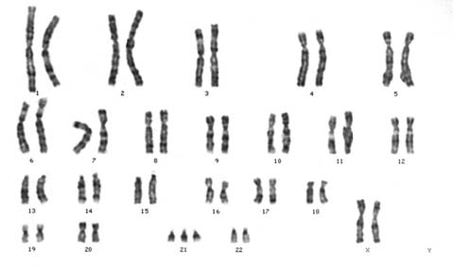
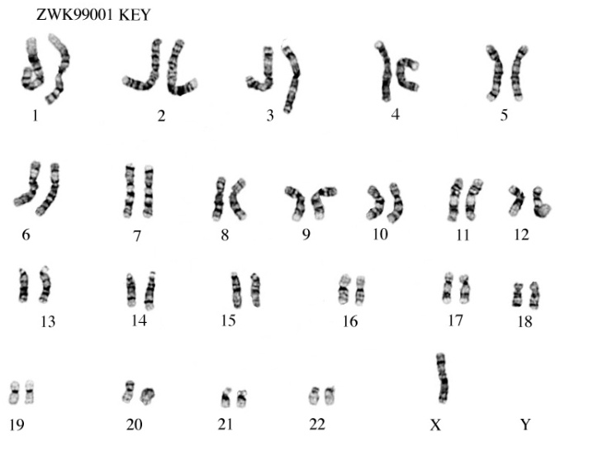

Knowing what you know: reflect on this unit and answer the questions that follow.
What are you doing to study?
What was the most challenging material in this unit? How did you learn it?
How much time do you spend every day looking over/reviewing notes?
Have you asked your peers to help you understand material?

Include any thoughts on whether you think you are doing as much as you should be to ensure your success in school. Be honest – no one else will see this!

