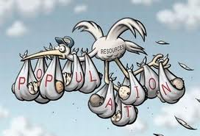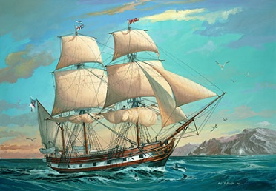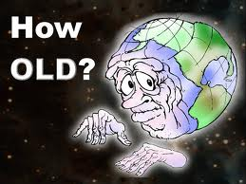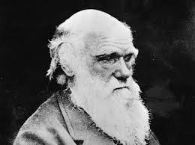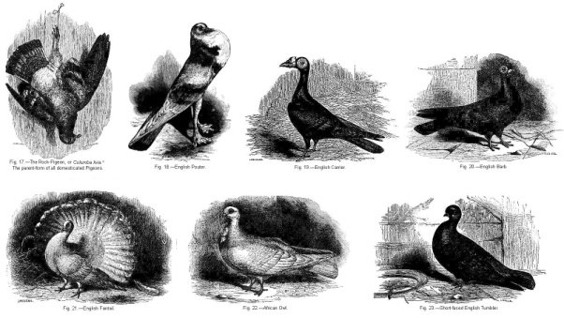

Economist; proposed that the human population grows faster than the world can sustain.

He suggested that starvation, disease, and competition kept populations in check.

**Darwin used this idea to explain why many species produce larger numbers of offspring than can survive.**

- Individuals will have to compete for resources and only the ones with some advantage will survive and reproduce. He referred to this as the struggle for existence.

- Darwin continued his studies for 2 decades. He collected more specimens and read the writings of individuals who helped him formulate his ideas.

Geologist; proposed that the Earth was very old (at the time, people thought it was only a few thousand years old.

He suggested that all the processes that produced changes in the past must be the same ones we see today.

**Darwin applied this concept to changes in species.**

- English scientist who explained natural selection as the *mechanism* for evolution.

- Traveled on the HMS Beagle as the ship’s naturalist (biologist)

Spent 5 years collecting specimens (biological, fossil)

- Darwin’s finches: prime example of specimens which he found interesting; species were unique to each island but had similarities between each other.

**Change** in population over *time* (specifically over *generations*)

Darwin also worked with pigeons. He noticed that a variety of traits are inherited in a population.

He artificially selected pigeons with specific traits to produce offspring with those traits. This helped him develop his idea of:

**Natural Selection** – currently accepted mechanism for evolution; variations in offspring may be more or less favorable for a particular environment.

Those with the more favorable variations will survive and produce offspring with those variations.

“Nothing in biology makes sense except in the light of evolution.”

-- Theodosius Dobzhansky, Geneticist

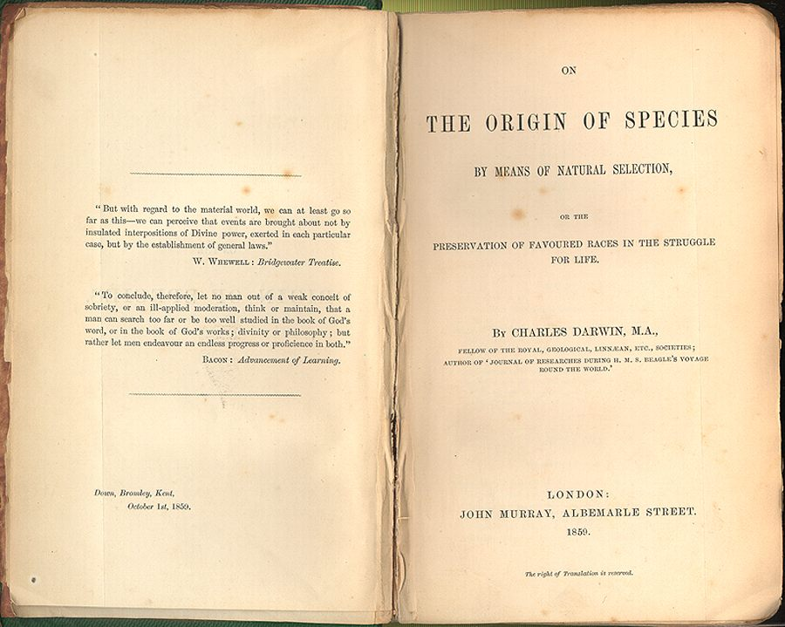

- Darwin did not **invent** evolution. Ideas about evolution had already been proposed – he simply came up with a plausible mechanism for evolution.

- Darwin did not have an epiphany about natural selection while he was on the Galapagos Islands. He did a great deal of studying, research, and reading before fully formulating his idea.

- Darwin was not an atheist. He was a deist who believed that some intelligence had set up the laws of nature in the first place. He also did not return to Christianity on his deathbed.

- Darwin did not claim that humans evolved from monkeys or apes. He proposed that we *may* have a common ancestor.

Many people have tried to make Darwin out to be a villain who sought to destroy Christianity.

In reality, he was simply searching for truth in nature.

He was never fully satisfied with his evidence – he continued to look for more. He was also working on other projects at the time.

Alfred Russel Wallace was a young naturalist who came to a similar conclusion about how evolution must proceed. Instead of seeming like he stole the idea from Wallace, Darwin decided to present his ideas to the scientific community with Wallace.

This finally prompted Darwin to publish his book –

**“On the Origin of Species by Means of Natural Selection”**

|  |  |
| --- | --- |
| **illustration of geological strata containing an evolutionary sequence of fossils from 570 to 2 million years agoFossil Record**  Fossil – *evidence* of an organism that  lived long ago.  Tell us a lot about conditions where  organisms lived, how and when they lived, etc.  **Relative dating** – approx. age of rock (and  organisms) based on nearby rocks.  **Radiometric dating** – more precise age, using the  half-life of radioactive isotopes. | **https://encrypted-tbn1.gstatic.com/images?q=tbn:ANd9GcS2oSN5Re2ReTmW4FUjeNe4ramHUNLG8PhJV7j44teMRMu2OPhC Chemical Similarities**  99% of the molecules in living things are made  from only 6 of the 92 most common elements.  There are only 4 DNA nucleotides in all living  things, and only 20 different amino acids which make up all proteins.  There are more similarities in DNA and proteins between organisms that are closely related than those which are more distantly related. |
| **http://jfk-science-wiki.wikispaces.com/file/view/g-d_of_living_species.jpg/221470108/705x264/g-d_of_living_species.jpgGeographic Distribution**  Major isolated land areas and islands  have their own distinct plant and  animal communities.  Since land masses have separated,  species have diverged into distinctly separate species. | **http://bio3vo.files.wordpress.com/2011/04/analogous-structures.jpg Anatomical Similarities**  Organisms that have similar body structures  inherited them from a common ancestor.  **Homologous structures** – structures that  share a common ancestral origin.  **Analogous structures** – have a similar  function but do not share a common  ancestral origin. |

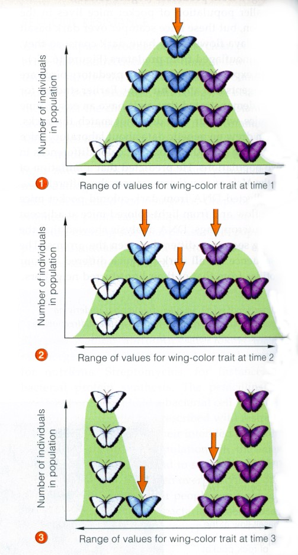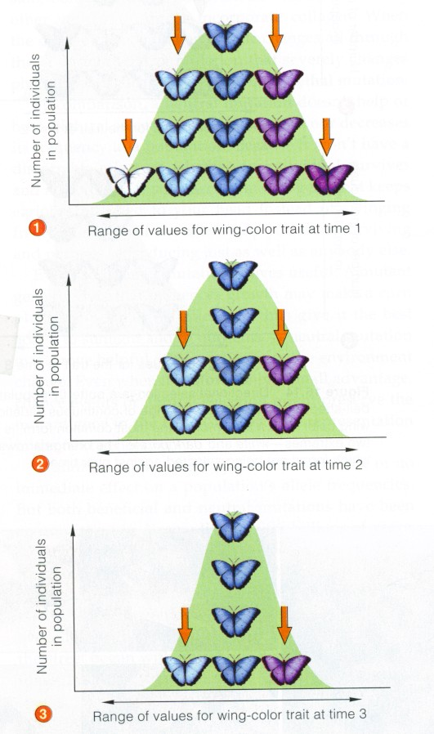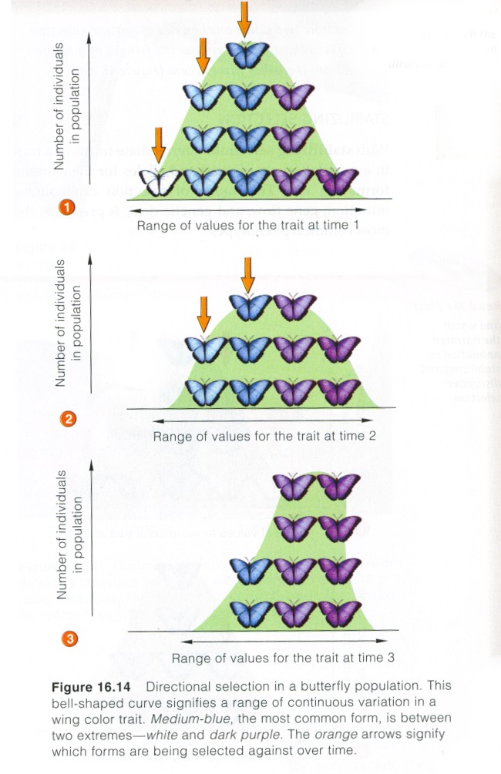

**“Survival of the Fittest”**

Fitness refers to an individual’s ability to survive and reproduce in their specific environment. Darwin proposed that fitness is a result of adaptations.

Adaptation – inherited characteristic which increases an organism’s chance of survival.

Darwin’s **“descent with modification”** refers to living species descending with changes from other species over time – a result of natural selection. This implies that all organisms are related to one another leading to the principle known as **“common descent**.**”**

- Individuals do not evolve; POPULATIONS EVOLVE

- Evolution acts on *variations* in traits depending on which

variations are favorable in a particular environment. - Mutations are a major source of those variations.

With simple traits where there are only 2 variations, one may be favorable over another. Individuals with the favorable trait are more likely to survive to reproduce.

When there is a range in the variations (white – light gray – dark gray – black), there are 3 types of natural selection that can occur.

|  |  |
| --- | --- |
| **Gradualism –** the idea that new species arise through a gradual change, adaptations building up over time. | **Punctuated Equilibrium –** the idea that new species arise quickly with long periods of equilibrium (no change) in between rapid bursts of change. |
| gradualism vs punctuated equ.gif | |

Both gradualism and punctuated equilibrium can result in speciation (there isn’t one “right” one) depending on the circumstances. There can be gradual change for long periods of time punctuated by dramatic environmental changes which can cause rapid changes.

**Patterns in Evolution**

**Divergent Evolution** – species that were similar to a common ancestor have become distinct species. Adaptive radiation is a type of divergent evolution in which an ancestral species evolves into many different species which fit in diverse habitats (Darwin’s finches exhibit adaptive radiation).

Results in **homologous structures**

**Convergent Evolution** – unrelated species evolve similar structures; similar environments may create similar pressures of natural selection causing different organisms to evolve similar adaptations.

Results in **analogous structures**

**Coevolution** – two species affect each other’s evolution.

– The evolution of new species (when members of the same population can no longer interbreed successfully). Species must undergo *reproductive isolation* for speciation to occur.

Reproductive isolation includes genetic (DNA has become too different for fertilization), behavioral (mating at different times of year), or mechanical (sex organs are incompatible).

**Geographic Isolation –** when a population is divided by a physical barrier such as a river. Over time, the populations may adapt to their individual environments, resulting in reproductive isolation.

**Temporal Isolation –** mating takes place at different times of day/year.

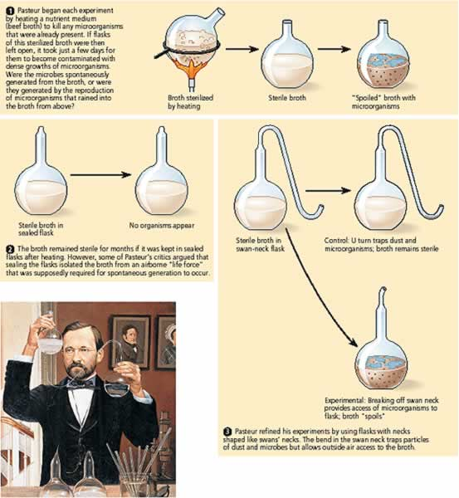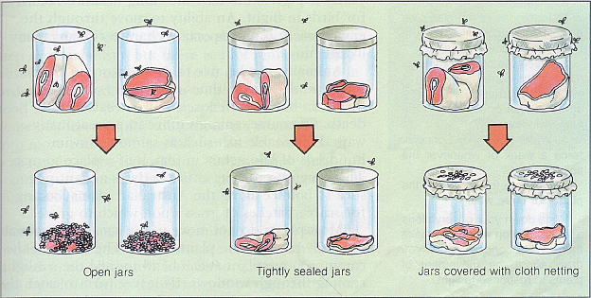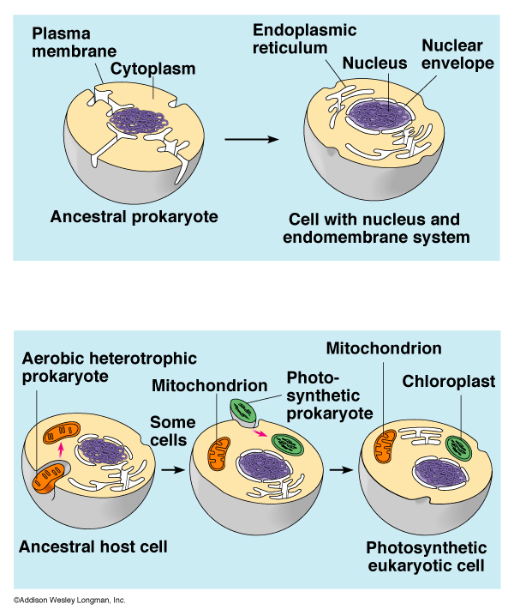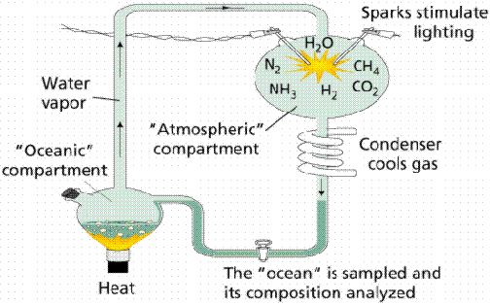

- The idea that life comes from nonliving material.

**Francesco Redi** disproved spontaneous generation (aka: **abiogensis**).

- Using decaying meat, he set up an experiment to show that meat could not produce maggots (immature flies).

- The uncovered meat (control group) had maggots at the end.

- The covered meat (experimental group) did NOT have maggots.

- Flies were not able to get into the experimental group to lay eggs.

Redi disproved spontaneous generation of large organisms, but the invention of the microscope enabled scientists to see that microorganisms were everywhere. They assumed that microorganisms must arise spontaneously with the help of some force in the air.



**Louis Pasteur** disproved spontaneous generation of microorganisms.

- His experiment used flasks which allowed air to come in contact with a nutrient-rich broth, but no microorganisms. If there *was* some force in the air, then microorganisms should appear.

- Even though the broth was in contact with air, no microorganisms appeared.



After Pasteur’s experiment, the idea that living organisms only come from other living organisms – **biogenesis** – was accepted.

Biogenesis still doesn’t explain how life began on Earth. Scientists have developed theories from testing the hypotheses about the conditions of early Earth.

Scientists are not *sure* that Earth formed in any particular way... but, it **IS** possible to use indirect evidence to formulate ideas of what it might have been like.

- Probably very hot due to meteorites heating its surface and compression of minerals and decaying materials heating its interior.

- Volcanoes frequently erupted, releasing gases which formed early Earth’s atmosphere – consisting of water vapor, carbon dioxide, nitrogen and other gases, but NO FREE OXYGEN.

- Cooled enough for water to condense and fall as rain (for millions of years) – enough to make Earth’s oceans.

- Life may have originated in Earth’s oceans between 3.9 and 3.4 billion years ago.

After the formation of small organic molecules, there must have been formation of larger, more complex molecules such as proteins.

**Sidney Fox** showed that short chains of amino acids would form clusters which appeared to carry out some of life’s activities (growth and division).

- Prokaryotic (simple) and anaerobic (since there was no oxygen).

- Heterotrophs because they could not make their own food.

- Before food sources were depleted, autotrophs probably evolved (made food themselves via chemosynthesis rather than photosynthesis). These would be similar to today’s archaebacteria which can live in very harsh environments and photosynthesize.

The environment started to change once photosynthetic organisms began producing **oxygen**.

Organisms that could use oxygen for respiration (aerobic) would thrive.

As organisms became more complex, eukaryotes would ultimately evolve.

- explains the evolution of eukaryotes.

Eukaryotes evolved through a relationship between prokaryotes.

**Evidence:**

- Both mitochondria and chloroplast resemble some present-day prokaryotes, they each have their own DNA (more similar to prokaryotic DNA than to nuclear DNA in eukaryotes), they have their own ribosomes, and they can reproduce independently of the cells.

**Alexander Oparin**’s hypothesis about the origin of life:

- Life began in the oceans and energy from the sun, lightning, and Earth’s heat resulted in chemical reactions that produced small organic molecules from the substances present in the atmosphere.

- Rain washed the molecules into the ocean – often called primordial soup

**Miller** and **Urey** tested Oparin’s hypothesis.

- They simulated Earth’s early conditions in the lab.

- Mixed water vapor with ammonia, methane, and hydrogen and then added an electric current to simulate lightning.

- Cooled the mixture of gases producing a liquid which they collected in a flask. After one week, they found several kinds of amino acids, sugars, and other small organic molecules.

