2016 7th Grade Science MSL Study Guide

**Physics**

* Position – the exact location of an object.
* Direction – the line or course along which something moves.
* Speed – measures how fast an object is moving in a given amount of time.Speed= Distance/Time
* Motion – the change in position of an object.
* Force – push or pull
* Friction - a force that opposes (goes against) motion. Friction is created when two surfaces rub together.
* Newton’s 1st Law of Motion: an object at rest will stay at rest and an object in motion will stay in motion until a force acts upon it.
* Inertia – the tendency for an object to keep doing what it is doing (resting or moving)
* Mass – the amount of matter (“stuff”) - in an object.
* Weight - the amount of force (pull) that gravity has on an object's mass. Your weight depends on
* the gravitational pull of your location.
* Gravity – a force that attracts (pulls) all objects to the center of the Earth
* Acceleration – the changes in an object’s motion. This can be speeding up, slowing down or changing direction. An object’s acceleration depends on the object’s mass and the force applied.
* Newton’s 2nd Law of Motion – the acceleration of an object depends on its mass and the force used to move it

F=MA F = force M = mass A = acceleration

* Velocity – measures how fast an object is moving (speed) AND the direction in which it is moving
* Momentum - the higher the velocity and mass, the more momentum an object has. One way to think of momentum is that momentum measures how hard it will be to stop the object once it is in motion. Momentum can be transferred when two objects collide.
* Newton’s 3rd Law of Motion – for every action there is an equal and opposite reaction
* Net force – the overall force(s) acting on an object.
* Balanced force - does not cause a change in motion. Is equal in size and opposite in direction. Net force = ZERO
* Unbalanced force - always causes a change in motion. Is not equal and opposite. Net force is GREATER than zero.
* Energy – the ability to do work
* Kinetic energy – energy of motion.
* Potential energy – stored energy in a body or system due to its position.
* Reference Point- a basis or standard for comparison

**Layers of the Atmosphere and Weather:**

* As you rise up through the atmosphere, air pressure and temperature change dramatically.
* **Scientists divide Earth's atmosphere into four main layers classified according to changes in temperature. These layers are the troposphere, the stratosphere,- the mesosphere, and the thermosphere.**
* You live in the inner, or lowest layer of Earth's atmosphere, the **troposphere. The troposphere is the layer of the atmosphere in which Earth's weather occurs. The** depth of the troposphere varies from 16 kilometers above the equator to less than 9 kilometers above the North and South **Poles.**
* **The stratosphere** extends from the top of the troposphere to about 50 kilometers above Earth's surface. **The stratosphere is the second layer of the atmosphere and contains the ozone layer.** The ozone layer is important because it protects Earth's living things from dangerous ultraviolet radiation from die sun.
* Above the stratosphere, a drop in temperature marks the beginning of the next layer, the **mesosphere- The** mesosphere begins 50 kilometers above Earth's surface and ends at an altitude of 80 kilometers. **The mesosphere is the layer of the atmosphere that protects Earth's surface from being hit by most meteoroids.**
* **The outmost layer of Earth's atmosphere is the thermosphere. The thermosphere extends** from 80 kilometers above Earth's surface outward into space. It has no definite outer limit, but blends gradually with outer space.
* The thermosphere is divided into two layers. The lower layer, called the **ionosphere,** begins about 80 kilometers above the surface and extends to about 400 kilometers. Gas molecules here are electrically charged because of the sun's energy. Radio waves bounce back from the ionosphere to Earth’s surface. The brilliant light displays called auroras also occur in the ionosphere. The outer layer of the thermosphere is the **exosphere.**
* What is the composition of the air and the percentage:

78% **nitrogen**, 21% oxygen, 1% other gasses ( 0.93% argon, 0.039% **carbon dioxide**, and small amounts of other gases)

* **Meteorologist**: forecast (predict) the weather; sometimes they are right and sometimes they are wrong. Forecasting the weather is no easy task.
* **Weather**- describes the conditions in the atmosphere (mostly the troposphere the lowest layer of the atmosphere) at a given place for a short period of time. It is caused by the uneven heating of the earth by the Sun’s rays

**Weather Variables**

The change in weather is described by a series of **weather variables.** These weather variables include **Air Temperature, Air Pressure, Humidity, Wind Speed, Wind Direction, and Precipitation**

**Air Temperature-**the amount of heat energy in the atmosphere at a place

**Air Pressure-** is the amount of force exerted by the air hitting a given surface area

**Humidity-** the amount of water vapor in the air

**Wind Speed-**the rate of moving air

**Wind Direction-** the direction that the wind blows **FROM**

**Precipitation-**failing moisture from clouds (Rain, Snow, Sleet, and Hail)

|  |  |  |  |
| --- | --- | --- | --- |
| **Weather Variable** | **Definition** | **Units** | **Instrument** |
| **Air Temperature** | The amount of heat energy in the atmosphere as a place | 0F (Fahrenheit) or  0C (Celsius) | **Thermometer** |
| **Air Pressure** | The amount of force exerted by the air hitting a given surface area | millibars (mb) | **Barometer** |
| **Humidity** | The amount of water vapor in the air | Relative Humidity expressed in percent % | **Sling Psychrometer** |
| **Wind Speed** | Moving air | Knots or miles per hour (K or mph) | **Anemometer** |
| **Wind Direction** | The direction that the wind is blowing **FROM** | North, East, South, West | **Wind Vane** |
| **Precipitation** | Forms of water that fall from clouds example: **Rain, snow, sleet, hail, or freezing rain** | Inches, or centimeters | **Rain gauge** |

**Air Masses and Fronts**

Weather forecasts are based on the movements of air masses. By observing and predicting their paths meteorologists and forecast the weather to help you plan your daily activities and decisions.

**Air Mass-** air with generally uniform characteristics

**Source Region-** the surface over which an air mass forms

**Front-** The boundary (on the ground) between two air masses

|  |  |  |  |
| --- | --- | --- | --- |
|  | Arctic: **A** | Polar: **P** | Tropical: **T** |
|  | Formed over extremely cold , ice covered regions | Formed over regions of high latitudes where temperatures are relatively low | Formed over regions of low latitudes where temperatures are relatively high |
| maritime: **m**  Formed over water, moist |  | **mP**- cold, moist  Formed over North Atlantic, North Pacific | **mT**-warm, moist  Formed over Gulf of Mexico, middle Atlantic, Caribbean, Pacific (south of California) |
| continental: **c**  Formed over land, dry | **cA-** dry, frigid  Formed north of Canada | **cP-** cold, dry  Formed over northern and central Canada | **Ct-** warm, dry formed over southwestern United States in summer |

**Fronts: Warm and Cold**

Fronts are where major changes in weather occur, cold air mass replaces a warm air mass the weather changes. Violent weather occurs at these locations including rain, strong winds, and abrupt changes in temperatures. Air masses typically move from **WEST to EAST** across the United States. The weather that occurred in Chicago today will be in New York tomorrow!

**Front-** the line on the ground marking the boundary between two air masses

**Cold Front-** the ground location where a cold air mass advances against a warmer air mass. The cold air mass is denser so it forces the warm up rapidly. This causes the warm air **rise, expand and cool.** This rapid condensation leads to heavy rain and/or thunderstorms. The temperature drops rapidly as a cold front passes!

**Warm front-** where a warm air mass pushed up and over a cold air mass. The warm air goes over the cold air gradually because it is less dense than the cold air. As the warm air **rises** it **expands, and cools.** This causes condensation to occur over a wide gently sloping boundary. This results in thick clouds and widespread precipitation.

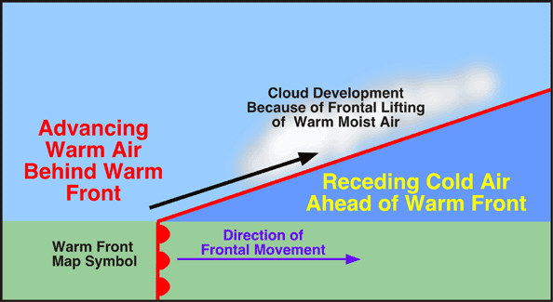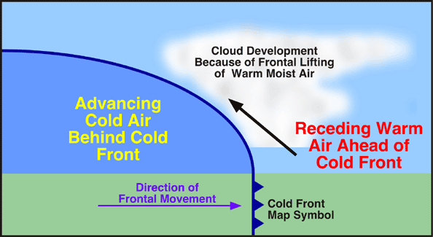

**Hurricane (Cyclonic systems)! Extreme Weather!**

Weather is extreme. Weather brings floods, causes landslides, and delivers hurricanes, tornados, thunder and lightning. Weather destroys homes, roads, and even the beach. Your life may be at risk from the weather!

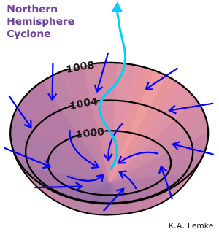**Cyclone**- any inward and counterclockwise air circulation around a low pressure center

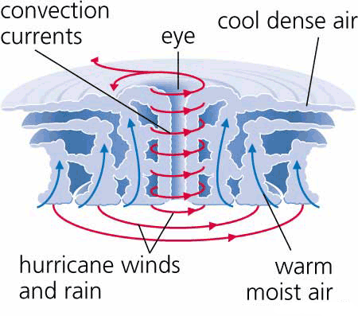**Hurricane: -**are huge cyclonic storms (Low Pressure systems) that form in the summer over warm ocean water. The energy from a hurricane comes from the sun as it evaporates water to fuel the hurricane! The wind blows counterclockwise around the center! Winds can blow from 74 -200+mph! Hurricanes can be larger than 500 km diameter! Coastal flooding and winds cause extensive damage during a hurricane!

**CELL:**

Cell Theory - Scientific theory that states:

1. All living organisms are composed of one or more cells. (Shliedan & Schwann)
2. Cells are the most basic unit for function and structure of all organisms. (Hooke)
3. All cells come from cells that already exist. (Virchow)

**Protist**  – a diverse group of organisms that are unicellular (with a few species of Multicellular organisms). All protists are eukaryotes.

**Eukaryotes** – organisms that have cells with a distinct membrane-bound nucleus and organelles.

**Photosynthesis** – a process in which organisms use light energy to join carbon dioxide and water to make nutrients.

**Chlorophyll** – a green pigment that captures the energy of the sun to drive photosynthesis.

**Euglena** – a unicellular protist that has some characteristics of both plants and animals. It has organelles that include an eyespot and flagellum

**Eyespot** – an organelle in the euglena that is sensitive to light and has no “eye sight.”

**Flagellum** – a whip-like tail that moves quickly back and forth to propel (or move) the protist through water.

**Amoeba** – a unicellular protist that is animal-like with organelles that include a pseudopod.

**Pseudopod** – an extension of the cytoplasm that forms when the cytoplasm extends (or stretches out) away from the nucleus. It is used by the amoeba for movement and engulfing its food.

**Paramecium** – a unicellular protist that is common in ponds and slow-moving streams. It is almost completely covered with tiny hairs called cilia. It is the only protist with two nuclei.

**Cilia** – the tiny hairs surrounding the cell used for movement.

**Oral groove** – an organelle used by the paramecium for feeding.

**Volvox** – a unicellular protist that has chloroplasts and can carry out photosynthesis. The Volvox lives and travels in colonies (or groups).

**Organelles:**

|  |  |  |
| --- | --- | --- |
| **Name** | **Prokaryotic/ Plant/Animal** | Function |
| Cell Membrane | Pro, A, P | * Separates the cell from outside environment * Selectively permeable |
| Cell Wall | Pro, P | * Additional support, protection * Gives cell its shape |
| Nucleus | A, P | * Controls the cell activities |
| Nuclear membrane/ Envelope | A, P | * Allows material to move into & out of Nucleus (RNA pass through pores) |
| Nuclear Pores | A, P | * Allow material to move into & out of Nucleus |
| Chromatin | A, P | * Condenses to form chromosome at the time of cell division |
| Chromosome | A, P | * Blueprint - controls cell activity * Pass on genetic info to next generation |
| Nucleolus | A, P | * Assembly of ribosomes take place here |
| Cytoplasm | Pro, A, P | * Chemical reactions take place here |
| Cytoskeleton | A, P | * Helps the cell to maintain its shape & 3 D structure, Cell movement |
| Ribosome | Pro, A, P | * Site of protein synthesis |
| Endoplasmic Reticulum | A, P | * Connects membrane, Moves material * Smooth E.R. – production & storage of carbs & lipid |
| Golgi Apparatus | A, P | * Sorts & packs protein into vesicle & transports them |
| Lysosome | A | * Digests food, bacteria, worn out organelle |
| Vacuole | P, A (small or none) | * Stores food, enzyme, and other material * Support |
| Mitochondrion | A, P | * Power house of cell – produces energy for growth, development, and movement |
| Centrioles/ Basal bodies | A | * Helps in cell division (mitosis) * Helps in forming flagella and cilia |
| Chloroplast | P | * Captures light & converts it into chemical energy * Pigment chlorophyll (photosynthesis) |

**Genetics:**

**Trait** – A characteristic caused by genetics or the environment

**Chromosomes** – Long strands of DNA that contain thousands of genes

**Genes** – Part of chromosome that controls a trait(30,000 in humans)

**Allele** – Different forms of genes

**Recessive allele** – Only see this trait if two are present

**Dominant Allele** – Always shows its trait

**Heterozygous/ Hybrid** – Has two different alleles for same trait

**Homozygous/Purebred** – Has two identical alleles for same trait

**Probability** – The likelihood that an event will occur

**Punnett Square** – A chart that shows all possible combinations of alleles between two organisms

**Phenotype** – The visibly expressed trait (ie. blue eyes)

**Genotype** – The allele combination for a trait (ie. Bb or bb.)

**Codominant Alleles** – Neither allele is dominant(ie. Blood types or spotted dog)

**Incomplete Dominance** – The dominant alleles mix – (Green flower from blue and yellow alleles)

**Meiosis** – Process that creates sex cells with one copy of each gene or half the number of chromosomes

**Mitosis** – Process that creates somatic (body) cells that are an exact copy of the original cell.

**# of human chromosomes** – 23 pairs or 46 chromosomes

**X and Y –** Human chromosomes that determine gender

**Mutation** – When a chromosome is not copied correctly

**Carrier** – Someone who has one recessive allele for a trait but doesn’t show it.

**Pedigree** – A chart that tracts a particular trait in a family

**Karyotype** - A picture of all the chromosomes of a cell

**Genome** – All the DNA in one cell of an organism

**Genotype** – An analysis of a genome to determine inherited traits

**Clone** – An organism that is genetically identical to the parent organism

**DNA – Deoxyribonucleic acid** – The molecule that is the base of all chromosomes

**Four bases of DNA** – Adenine and Thymine; Guanine and Cytosine

**Heredity** – The passing of traits from parent to offspring

**Sex-linked Gene** – A gene that is on the X or Y chromosome(hemophilia or color blindness)

**Gregor Mendel** – A monk in the 1850’s that studied how plants inherit traits

**Crick and Watson** – Two scientist who first described the DNA double-helix molecule

**Genetic Disorders** – Illnesses or disorders caused by an abnormal gene (Examples: Downs and Turner Syndrome -wrong number of chromosomes, Recessive traits - Sickle Cell Anemia, Cystic Fibrosis)

**Inherited Trait** – A trait totally controlled by your genes (ie. Eye color)

**Environmental Trait** – A trait that is expressed as a combination of your genes and the environment. (ie. Skin color)