**2016 7th Grade Science MSL Study Guide**

Name: ______________________ Date: _____ Period: ______

**UNIT 1: PHYSICS**

* Make sure you know the formulas for Speed, Distance, and Time:

1. A football field is about 100 m long. If it takes a person 20 seconds to run its length, how fast (what speed) were they running?
2. The pitcher’s mound in baseball is 85 m from the plate. It takes 4 seconds for a pitch to reach the plate. How fast is the pitch?
3. If you drive at 100 km/hr for 6 hours, how far will you go?
4. Every summer I drive to Michigan. It is 3900 km to get there. If I average 100 km/hr, how much time will I spend driving?
5. What is “Frame of reference”?
6. What is a force?
7. What are unbalanced forces and give an example?
8. What are balanced forces and give an example?
9. What are Newton’s 3 Laws?

Calculate the net force on the object described in each situation. Draw a free body diagram for each and show the directions of forces as well as the total net force and direction of net force.

Example: Mr. Whitmore lifts the heavy box over his head with one push of the arm and a force of 250 newtons. Gravity is pulling down the mass with 200 Newtons. What is the net force and direction of the box?

Force of Mr. Whitmore’s arm (250 N)

Net force = 50 N upwards

Force of gravity (200N)

1. A box is being pushed by two stellar science students, one on each side of the box. Dalton is pushing the box with a force of 10 N to the left. DeAndre is pushing the box with a force of 15 N to the right. Who is the stronger individual and what is the net force and direction on the box.
2. During tug of war Janelle felt she was supergirl and attempted to beat Rameek. Janelle with one arm on the rope and the other at her side applied a 100 N force to the left, while Rameek applied a 100 N force with both hands to the right. What is the net force and direction on the rope?
3. Janelle finally decided to take this seriously and put both hands on the rope and applied a 150 N force to the left, while Rameek still struggled with his 100 N force to the right. What is the net force and direction of motion.

**UNIT 2: Layers of the Atmosphere and Weather:**

* What is the composition of the air and the percentage:
* **___________________**: forecast (predict) the weather; sometimes they are right and sometimes they are wrong. Forecasting the weather is no easy task.
* **___________________**- describes the conditions in the atmosphere (mostly the troposphere the lowest layer of the atmosphere) at a given place for a short period of time. It is caused by the uneven heating of the earth by the Sun’s rays

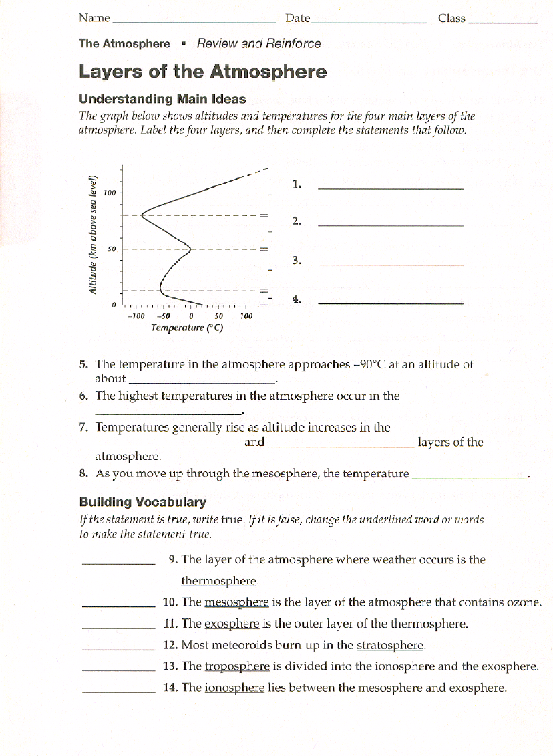

**Weather Variables**

The change in weather is described by a series of **weather variables.** These weather variables include **Air Temperature, Air Pressure, Humidity, Wind Speed, Wind Direction, and Precipitation**

**_______________________-**the amount of heat energy in the atmosphere at a place

**______________________-** is the amount of force exerted by the air hitting a given surface area

**______________________-** the amount of water vapor in the air

**______________________-**the rate of moving air

**______________________-** the direction that the wind blows **FROM**

**______________________-**failing moisture from clouds (Rain, Snow, Sleet, and Hail)

|  |  |  |  |
| --- | --- | --- | --- |
| **Weather Variable** | **Definition** | **Units** | **Instrument** |
| **Air Temperature** |  | 0F (Fahrenheit) or  0C (Celsius) | **Thermometer** |
| **Air Pressure** |  | millibars (mb) | **Barometer** |
| **Humidity** |  | Relative Humidity expressed in percent % | **Sling Psychrometer** |
| **Wind Speed** |  | Knots or miles per hour (K or mph) | **Anemometer** |
| **Wind Direction** |  | North, East, South, West | **Wind Vane** |
| **Precipitation** |  | Inches, or centimeters | **Rain gauge** |

**Air Masses and Fronts**

**______________-** air with generally uniform characteristics

**_______________-** The boundary (on the ground) between two air masses

|  |  |  |  |
| --- | --- | --- | --- |
|  | Arctic: **A** | Polar: **P** | Tropical: **T** |
|  |  |  |  |
| maritime: **m**  Formed over water, moist |  |  |  |
| continental: **c**  Formed over land, dry |  |  |  |

**Fronts: Warm and Cold**

**__________________** the ground location where a cold air mass advances against a warmer air mass. The cold air mass is denser so it forces the warm up rapidly. This causes the warm air rise, expand and cool.This rapid condensation leads to _____________________________. The temperature drops rapidly as a cold front passes!

[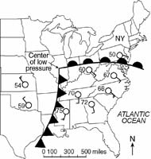](http://www.charlesburrows.com/regents2b/pages/regents525.htm)**______________-** where a warm air mass pushed up and over a cold air mass. The warm air goes over the cold air gradually because it is less dense than the cold air. As the warm air rises it expands, and cools**.** This causes condensation to occur over a wide gently sloping boundary. This results in ____________________________ & ___________________________.

**Questions:**

1. How do winds blow around a hurricane?
2. What fuels a hurricane and gives it its power!
3. To stay safe what should you do if a hurricane comes to Long Island? Go to the beach or move to higher ground?
4. [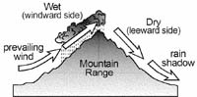](http://www.charlesburrows.com/regents2b/pages/regents450.htm)What cause the clouds and precipitation to form on the windward side of the mountain?
   1. Sinking, contracting, warming air
   2. Rising expanding and cooling air
5. What type of air mass is between the cold front and warm front?
6. Wind blow from____________ pressure to ________________ pressure.
7. A(n) ________________________ is used to measure wind speed.

[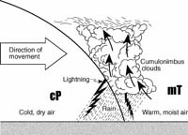](http://www.charlesburrows.com/regents2b/pages/regents595.htm)

1. What type of front is shown here:
2. Cold front
3. Warm front
4. Why is the warm air forced up in a cold front?
5. What is the relationship between temperature and latitude? (complete sentence)
6. What causes weather? (complete sentence)
7. Weather mostly occurs in the ____________________ the lowest layer of the atmosphere.

[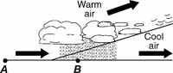](http://www.charlesburrows.com/regents2b/pages/regents130.htm)

1. What type of front is shown here:
2. ________________________ and strong ___________________ cause extensive damage during hurricanes!

**UNIT 3: CELLS:**

1. What’s the difference between Eukaryotes and Prokaryotes?

2. What is “Cell Theory” and who helped contribute to it?

1.

2.

3.

3. Name & Describe 4 types of protists:

1.

2.

3.

4.

|  |  |  |  |
| --- | --- | --- | --- |
| **Organelle** | **Description** | **Function** | **Animal, Plant or Both** |
| CELL WALL | Rigid, tough, made of cellulose |  |  |
| CELL MEMBRANE | Thin, covering, protects cells |  |  |
| CYTOPLASM | Jelly like substance that contains organelles |  |  |
| NUCLEUS | Dense, ball shaped structure, contains DNA |  |  |
| NUCLEAR MEMBRANE | Thin covering over the nucleus |  |  |
| CHROMATIN/  CHROMOSOME | In the nucleus, made of DNA and protein, contains genes |  |  |
| ENDOPLASMIC RETICULUM | Clear, tubular system of tunnels throughout the cell |  |  |
| RIBOSOME | Small specks made of RNA. Found in cytoplasm or on the endoplasmic reticulum |  |  |
| MITOCHONDRIA | Location in the cytoplasm, bean shaped |  |  |
| VACUOLE | Large open storage area, smaller in animal cells |  |  |
| CHLOROPLAST | Green structures that contain chlorophyll |  |  |
| GOLGI BODY | Small bags with tubes connecting them |  |  |
| LYOSOME | Small, round structures, containing enzymes |  |  |

**Use the table above to fill in the chart**

Complete the following table by writing the name of the cell part or organelle in the right hand column that matches the structure/function in the left hand column. A cell part may be used more than once.

|  |  |
| --- | --- |
| Structure/Function | Cell Part |
| Closely stacked, flattened sacs (plants only) |  |
| The sites of protein synthesis |  |
| Organelle that manages or controls all the cell functions in a eukaryotic cell |  |
| Contains chlorophyll, a green pigment that traps energy from sunlight and gives plants their green color |  |
| Digests excess or worn-out cell parts, food particles and invading viruses or bacteria |  |
| Small bumps located on portions of the endoplasmic reticulum |  |
| Provides temporary storage of food, enzymes and waste products |  |
| Firm, protective structure that gives the cell its shape in plants, fungi, most bacteria and some protests |  |
| Produces a usable form of energy for the cell |  |
| Packages proteins for transport out of the cell |  |
| Site where ribosomes are made |  |
| The membrane surrounding the cell |  |
| Provides support for the cell, has two “subparts” |  |
| Name for the collection of DNA in the nucleus of eukaryotic cells |  |
| Small hair-like structures used for movement or sensing things |  |
| Protects all cells and allows movement in and out of the cell. |  |
| Longer whip-like structures used for movement |  |

**UNIT 4: Genetics:**

1. What is heredity?

2. What is the difference between an allele and a gene?

3. What is DNA? Where can it be found? What is it made of? What is a chromosome?

4. Describe Mitosis and Meiosis. How are they similar and different:

5. What is the difference between sexual and asexual reproduction?

6. How is the father of genetics? Describe his experiment:

7. Draw a pedigree chart where a mother is a career and the father has the sex-linked trait. 2 of 3 songs have the trait, but their daughter does not have the trait.

8. For flower color, purple is dominant and white is recessive. A PP father and a PP mother are crossed.

What Genotypes and phenotypes are the parents?

What genotypes and phenotypes are the children?

9. _____________________ Dominance is when traits are blended (Black + White= Grey)

_______________________ Dominance is when both traits are expressed (Black & White spots)

10. How can environmental factors influence your genes?